Naming the Bones of the Body
11/9/2026
You can either name all the bones from the beginning or at the end.
Select the bone and hit F2
WATCH IT! If things go off the rails after parenting, check the names of each bone. They need to all be named using the L & R after a dot. There can be absolutely no spaces, or changes at all between the names, other than putting the R & L suffix at the end. Also if you are using _01, make sure you stick to that. Naming something even _001, can mess things up. You will be surprised at how important naming is, even in weight painting.

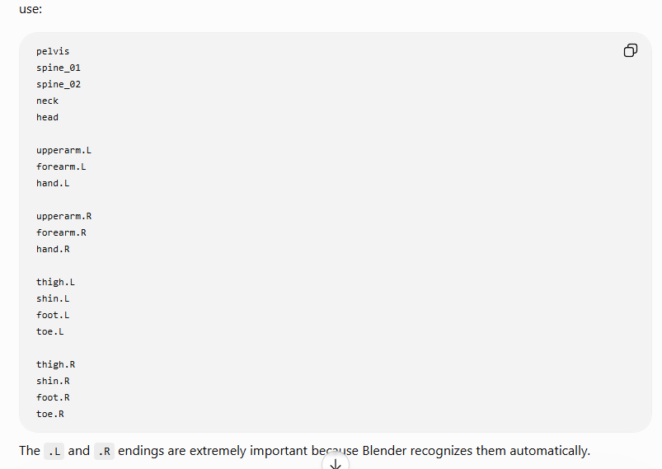
This might seem backwards but when we name these bones, we name them using the model’s left and right and not our own.
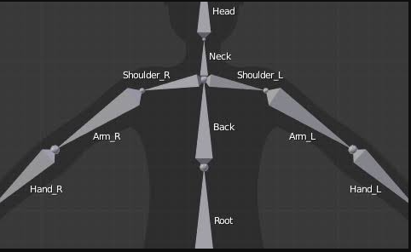
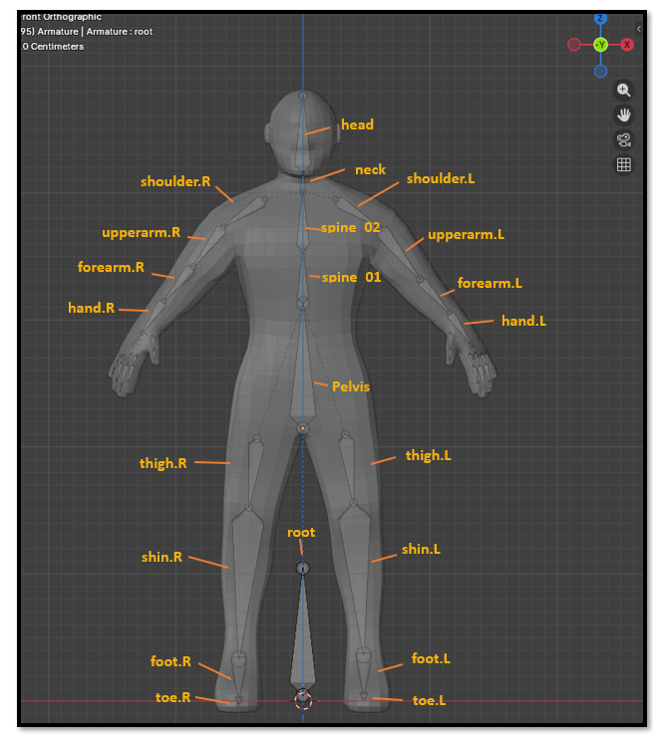

Naming the bones of the hand

The fingers are named from the hand bone toward the tip of the fingers.

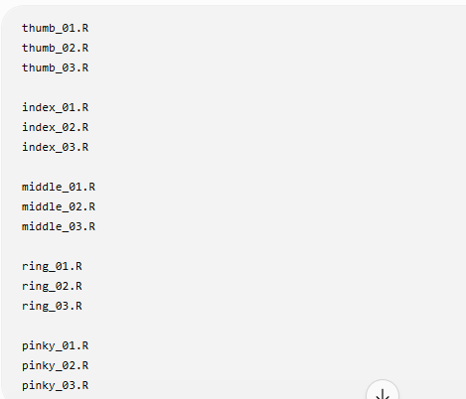

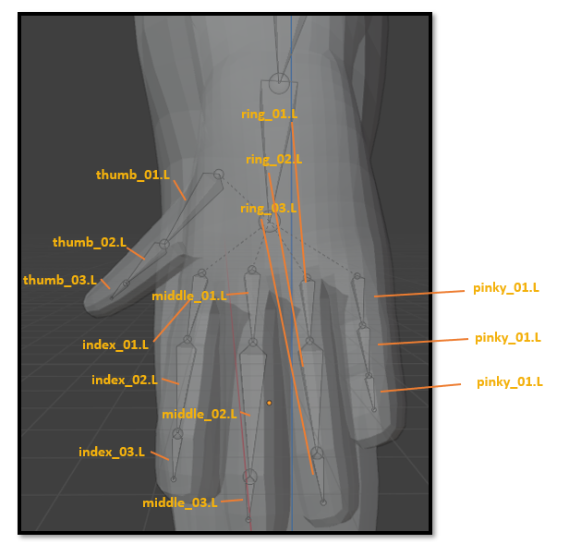
WATCH IT! If things go off the rails after parenting, check the names of each bone. They need to all be named using the L & R after a dot. There can be absolutely no spaces, or changes at all between the names, other than putting the R & L suffix at the end.

How to find the names in the Property Panel
There are two Armatures under Armature. The first one is actually your data information. So, select that one and drill down to see the bones. You must drill all the way down.
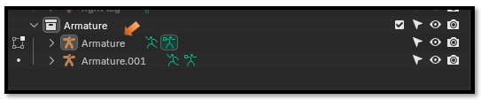
If a listed bone has a bone with numbers after it, this means you can open it to view more.
